 

**University of Westminster**

**Software Development I**

**4COSC006C**

TEST PLAN

Part 1

Name – Paththige Senuka Dinsara Fernando

UOW Number – w2053072

IIT Number - 20232114

|  |
| --- |
| **4COSC006C: Software Development I** **– TEST PLAN for Part 1** Seminar Day/Time: Module Tutor(s):  Lectures – Tuesday 10.30 am to 12.30 pm Mr. Saman Hettiarachchi (leader)  Tutorials – Moday 8.30 am to 10.30 am Mr. Dinusha Ruwan Kumara  Mr. Raveen Sriskandarajah |

**Test Case Table**

|  |  |  |  |  |  |
| --- | --- | --- | --- | --- | --- |
|  | Student Name: P. Senuka Dinsara Fernando Student ID: w2053072 | | | | |
|  | TEST PLAN for Part 1 : | | | | |
| Test Component | Test No. | Test Input | A - Expected Result | B - Actual Result  (or state ‘not attempted’) | Pass/Fail  (‘A’ matches ‘B’ == Pass) |
| Progress | 1 | Pass = 120  Defer = 0  Fail = 0 | ‘Progress’ displayed | ‘Progress’ displayed | Pass |
| Progress (module trailer) | 2.1 | Pass = 100  Defer = 20  Fail = 0 | ‘Progress (module trailer)’ displayed | ‘Progress (module trailer)’ displayed | Pass |
| 2.2 | Pass = 100  Defer = 0  Fail = 20 | ‘Progress (module trailer)’ displayed | ‘Progress (module trailer)’ displayed | Pass |
| Module retriever | 3.1 | Pass = 80  Defer = 20  Fail = 20 | ‘Module retriever’ is displayed | ‘Module retriever’ is displayed | Pass |
| 3.2 | Pass = 60  Defer = 0  Fail = 60 | ‘Module retriever’ is displayed | ‘Module retriever’ is displayed | Pass |
| 3.3 | Pass = 40  Defer = 80  Fail = 0 | ‘Module retriever’ is displayed | ‘Module retriever’ is displayed | Pass |
| 3.4 | Pass = 20  Defer = 40  Fail = 60 | ‘Module retriever’ is displayed | ‘Module retriever’ is displayed | Pass |
| 3.5 | Pass = 0  Defer = 60  Fail = 60 | ‘Module retriever’ is displayed | ‘Module retriever’ is displayed | Pass |
| Exclude | 4.1 | Pass = 40  Defer = 0  Fail = 80 | ‘Exclude’ displayed | ‘Exclude’ displayed | Pass |
| 4.2 | Pass = 20  Defer = 0  Fail = 100 | ‘Exclude’ displayed | ‘Exclude’ displayed | Pass |
| Validation | 5.1 | Pass = a | ‘Integer required’ | ‘Integer required’ | Pass |
| 5.2 | Pass = 5 | ‘Out of range’ | ‘Out of range’ | Pass |
| 5.3 | Pass = 100  Defer = 40  Fail = 0 | ‘Total incorrect’ displayed | ‘Total incorrect’ displayed | Pass |
| Loops for multiple inputs | 6.1 | Program loops | Predicts multiple progression outcomes | Stored multiple progression outcomes | Pass |
| 6.2 | Enter ‘q’ | Exits loop | Exits loop | Pass |
| Histogram | 7.1 |  | Window pops up and renders graph. Includes values for Progress, Trailer, Retriever and Excluded | Window pops up and renders graph. Includes values for Progress, Trailer, Retriever and Excluded | Pass |
| 7.2 |  | Shows outcomes in total. | Shows outcomes in total. | Pass |

**Test Cases Screenshots**

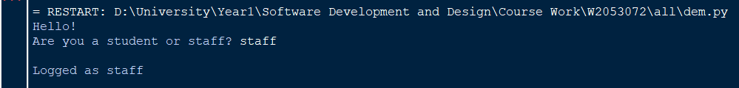

: Progress

: Progress (module trailer)

: Do not Progress – module retriever

: Exclude



: Validation 5.1

: Validation 5.2

: Validation 5.3

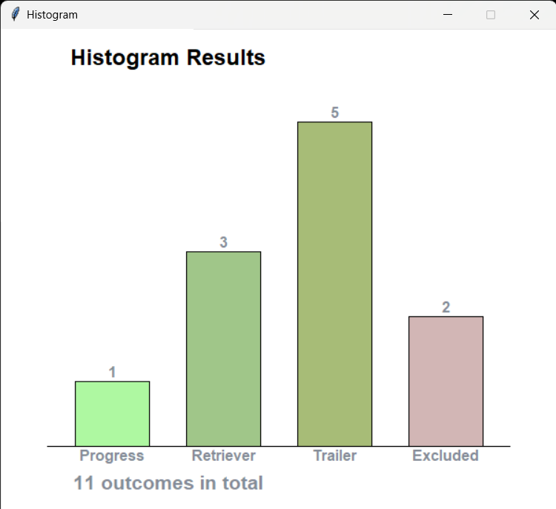

: Histogram 7.1

: Histogram 7.2